Maurion Caldwell

Comp Graphic and Visualization

2-3 Milestone One: Project Proposal

3/16/2025

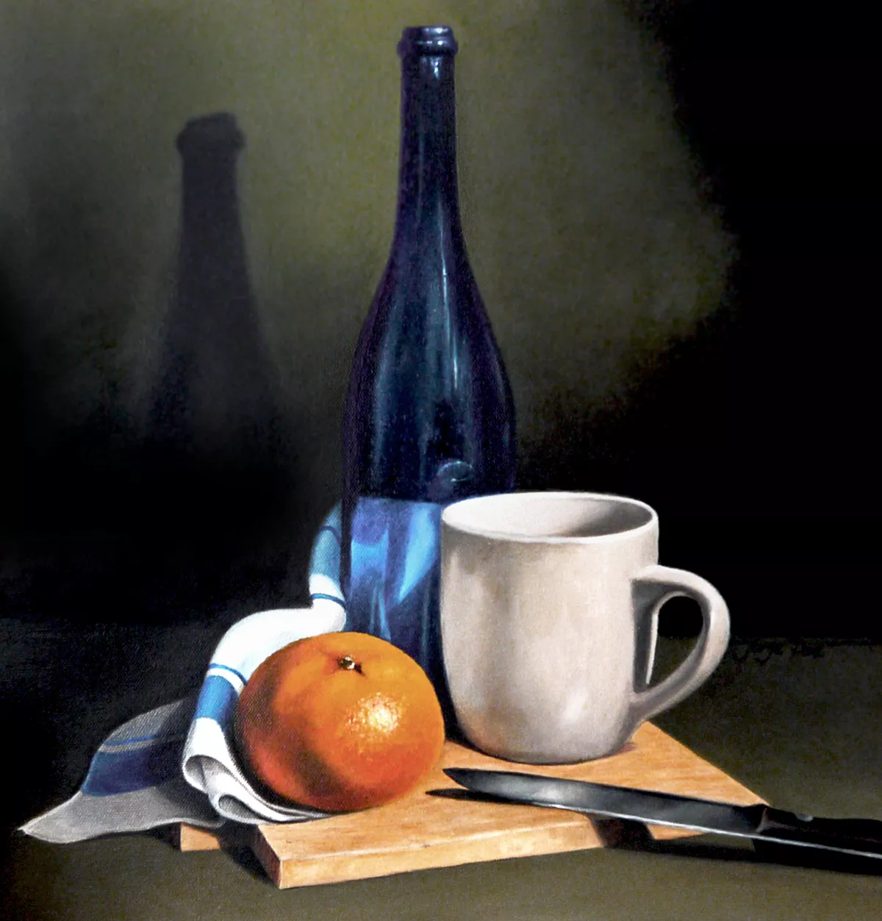

3D Scene Proposal

**1. Selected 2D Image with Objects to Replicate in a 3D Scene**

The 2D image I selected is a realistic still life painting featuring a blue glass bottle, a beige ceramic mug, an orange fruit, a metal knife, a folded cloth, and a wooden cutting board. This scene includes at least four distinct objects and meets the assignment requirement of using at least four different basic 3D shapes. It is well-suited for 3D modeling because it provides a range of textures, materials, and forms, such as reflective surfaces (the bottle and knife), soft fabric, organic fruit, and hard surface objects like the mug and board.

**2. Objects to Be Replicated in 3D**

In my 3D scene, I will replicate the following objects:

**Blue Bottle:** This will serve as a central vertical form and is visually striking with its height and shine.

**Ceramic Mug:** A useful object to demonstrate the combination of a cylindrical body with a torus-style handle.

**Orange:** Represents an organic object and introduces a smooth spherical shape with natural texture.

**Knife:** A metallic, reflective object that adds sharp contrast and variety.

**Cutting Board:** A simple rectangular base that helps define the composition of the still life.

**Table Surface:** This will act as the ground plane to anchor the objects in space.

These objects were selected because they allow me to explore a variety of forms and modeling techniques. The mix of materials (glass, ceramic, metal, fruit, wood, and fabric) also makes this scene a great opportunity to practice applying realistic textures and lighting.

**3. Basic 3D Shapes Used to Replicate the 2D Objects**

Each object will be broken down into its component 3D shapes:

**Blue Bottle:**  
 The bottle will be created using a tapered cylinder for the body and cylinder for the neck. The smooth curvature at the bottom can be shaped using subdivision modeling or slight tapering to mimic the rounded glass base.

**Ceramic Mug:**  
 The main body of the mug will be a cylinder, and the handle will be shaped using a torus or a curved prism depending on how stylized the model becomes. This object uses at least two 3D shapes, meeting the assignment's composite-object requirement.

**Orange:**  
 This object will be a simple sphere, slightly adjusted for realism using sculpting or displacement to simulate the texture of orange skin.

**Knife:**  
 The handle of the knife will be created with a box (prism), while the blade will be modeled using an elongated prism with a tapered edge to simulate sharpness.

**Cutting Board:**  
 A box will be used to represent the board with wood texture applied. Its straight edges contrast with the organic form of the fruit.

**Table Surface:**  
 A plane will be used to ground all the other objects and create the sense of space in the 3D environment.

This 3D scene will utilize at least six different basic 3D shapes: plane, box, cylinder, tapered cylinder, torus, and sphere. The bottle and mug both involve multiple shapes, satisfying the requirement for at least one composite object.

**sources**

Birn, J. (2013). *Digital lighting and rendering* (3rd ed.). New Riders.  
 Bourne, K. (2021). *Blender 3D modeling: A practical guide to mastering basic sculpting and modeling techniques*. Packt Publishing.  
 Hearn, D., & Baker, M. P. (2014). *Computer graphics with OpenGL* (4th ed.). Pearson.  
 Kerlow, I. V. (2009). *The art of 3D computer animation and effects* (4th ed.). Wiley.